The Theme of History: THE KINGDOM OF GOD
From Introduction to Biblical Doctrine by John MacArthur and Richard Mayhue
This Photo by Unknown Author is licensed under CC BY-SA
he one constant theme unfolding throughout the whole Bible is this: God for his own glory has chosen to create and gather to himself a group of people to be the subjects of his eternal kingdom, who will praise, honor, and serve him forever and through whom he will display his wisdom, power, mercy, grace, and glory.

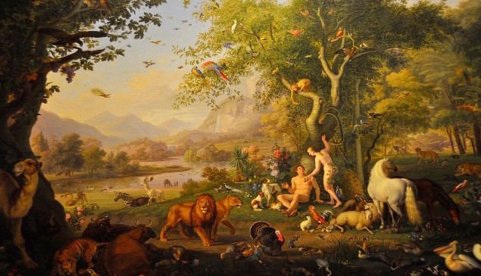
The kingdom of God can be explained in this manner: The eternal triune God created a kingdom and two kingdom citizens (Adam and Eve) who were to have dominion over it. But an enemy deceived them, seduced them into breaking allegiance to the King, and caused them to rebel against their sovereign Creator. God intervened with consequential curses that exist to this day. Ever since, he has been redeeming sinful, rebellious people to be restored as qualified kingdom citizens, both now in a spiritual sense and later in a kingdom-on-earth sense. Finally, the enemy will be vanquished forever, as will sin.
This Photo by Unknown Author is licensed under CC BY-ND

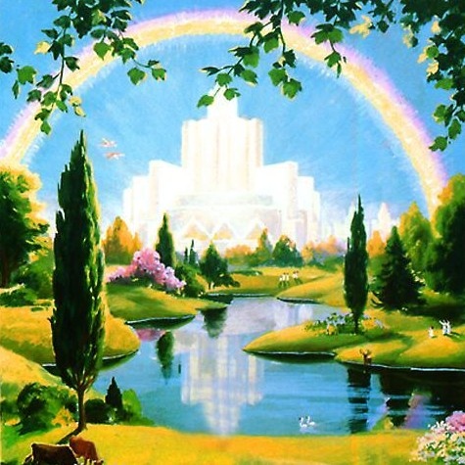
This Photo by Unknown Author is licensed under CC BY-SA-NC
Thus, Revelation 21-22 describes the final and eternal expression of the kingdom of God, where the triune God will restore the kingdom to its original purity with the curse having been removed and the new heaven and new earth becoming the everlasting abode of God and his people.

